|  |  |
| --- | --- |
| **MD. Rafeed Talukder**  **Address**: 44/3,West Dhanmondi,Hira Mahal.  **Email**: rafeed717@gmail.com  **GitHub**: <https://github.com/rafeed-talukder>  **Contact No**: +880-1677822784 |  |
| ***Objectives:***  **Computer engineer student with almost 1year of web development experience, both technically focused and customer oriented.** | |

**Working Experience**

* **Intern** at **Rightangle-IT (February 2018 to Present)**

o **Working Tools** - PYTHON [Basic, Basic OOP], HTML5, CSS3, Bootstrap

**Academic Credentials**

|  |  |  |  |  |
| --- | --- | --- | --- | --- |
| **Examination**  **Passed** | **Institution** | **Group/Dept.** | **Year** | **GPA/CGPA** |
| B.Sc. | University of Asia  Pacific | CSE | **2019** | 3.09 (Scale of 4)  [Current Semester 4-2] |
| H.S.C | Sirajganj Govt College ,Sirajganj | Science | **2014** | 4.70(Scale of 5) |
| S.S.C | B.L Govt High School , Sirajganj | Science | **2012** | 5.00(Scale of 5) |

**Undergraduate Thesis**

* **A Machine Learning Approach for Diabetes detection and Care in**

**Bangladesh**

* **( http://gjet.gyancity.com/Vol4No2/machine.pdf )**

**Relevant Skill**

• **Programming Language:**  Python

• **Proficiency:** Good Knowledge in

Database Design,

Software Development Process,

Web Development,

Android Development,

Android Mockup Design (UX/UI).

• **Framework**: Django (Learning)

• **Database**: MySQL(Basic)

• **Version Control System**: Git

• **Operating System**: Windows(xp,7,8,10), Linux.

**Significant Achievements**

* **Hackathon Contest:**
* **1st Runner-up** in Hackathon (UAP Inter-University Software &

Hardware Carnival - 2018)

* Participated **Software Contest(Hackathon)** in **SUST CSE**

**Carnival 2017**

**Project List**

**E-commerce Project**

**An offline System**

* **Programming Language :Basic PHP,HTML,CSS,BOOTSTRAP.**
* **Database: MySQL.**

**Car Management System (Front End Part)**

* **Programming Language :LARAVEL ,HTML ,CSS ,BOOTSTRAP.**
* **Database: MySQL.**

**BD-Tourism Project**

* **Programming Language : HTML,CSS,BOOTSTRAP.**

**I did many project using HTML , CSS ,BOOTSTRAP ,ANDROID STUDIO and also**

**have LIVE SERVER work experience. [LINK**: <https://github.com/rafeed-talukder>**]** .

**Certificate**

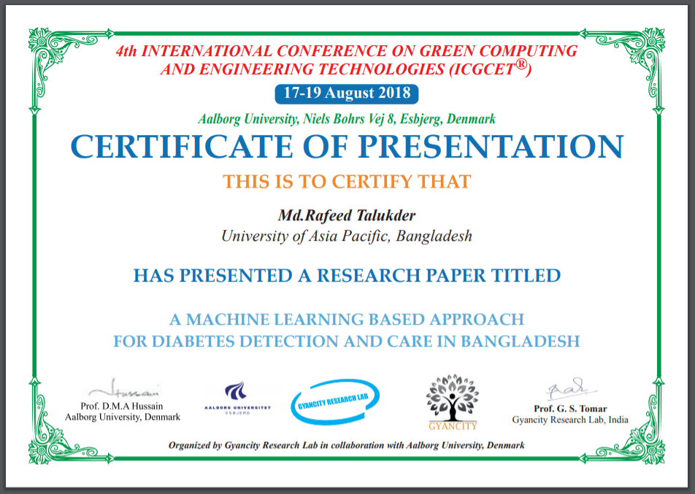

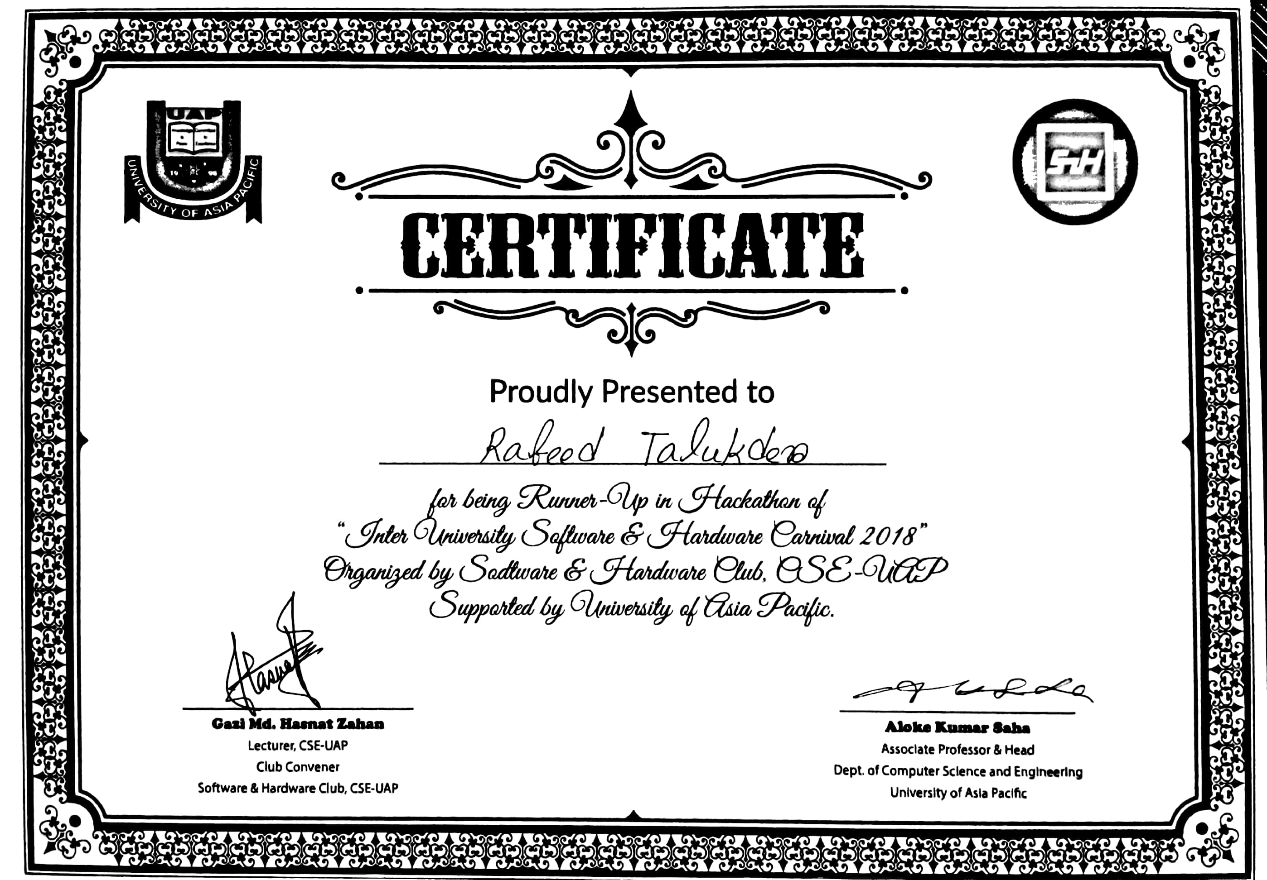

**Reference**

* **Shammi Akhtar**

**Assistant Professor, Department of Computer Science & Engineering**

**University of Asia Pacific**. Dhaka - 1205, Bangladesh

**Phone**: +88-02-9664951

**Fax**: +88-02-9664950

**Email**: shammi@uap-bd.edu